**LAPORAN PRAKTIKUM**

**PEMROGRAMAN PHYTON**



**Disusun oleh :**

Sandy Aryasatya Zamroni

V3922051

**PS D-IIITEKNIK INFORMATIKA**

**SEKOLAH VOKASI**

**UNIVERSITAS SEBELAS MARET**

**2022**

**Hasil Praktikum**

**Script**

from tkinter import *

import math

window = Tk()

window.title("Kalkulator GUI Dengan Python")

window.geometry('400x200')

lbl = Label(window, text="Masukkan Nilai Pertama : ",anchor="e",width=20)

lbl.grid(column=0, row=0)

lbl2 = Label(window, text="Masukkan Nilai Kedua : ",anchor="e",width=20)

lbl2.grid(column=0, row=1)

lbl3 = Label(window, text="Hasil : ",anchor="e",width=20)

lbl3.grid(column=0, row=2)

nilai1 = Entry(window,width=20)

nilai1.grid(column=1,row=0)

nilai2 = Entry(window,width=20)

nilai2.grid(column=1,row=1)

hasil = Label(window, text="0",anchor="w",width=10)

hasil.grid(column=1, row=2)

def tambah():

hasil.configure(text=(int(nilai1.get())+int(nilai2.get())))

def kurang():

hasil.configure(text=(int(nilai1.get())-int(nilai2.get())))

def kali():

hasil.configure(text=(int(nilai1.get())*int(nilai2.get())))

def bagi():

hasil.configure(text=(int(nilai1.get())/int(nilai2.get())))

def xpangkaty():

hasil.configure(text=(int(nilai1.get())**int(nilai2.get())))

def ypangkatx():

hasil.configure(text=(int(nilai2.get())**int(nilai1.get())))

def modulus():

hasil.configure(text=(int(nilai1.get())%int(nilai2.get())))

def xakary():

hasil.configure(text=(math.sqrt(int(nilai1.get()))))

def yakarx():

hasil.configure(text=(int(nilai2.get())**(1/int(nilai1.get()))))

btn = Button(window, text="Tambah", command=tambah)

btn.grid(column=0, row=3)

btn = Button(window, text="Kurang", command=kurang)

btn.grid(column=1, row=3)

btn = Button(window, text="Kali", command=kali)

btn.grid(column=0, row=4)

btn = Button(window, text="Bagi", command=bagi)

btn.grid(column=1, row=4)

btn = Button(window, text="X pangkat Y", command=xpangkaty)

btn.grid(column=0, row=5)

btn = Button(window, text="Y pangkat X", command=ypangkatx)

btn.grid(column=1, row=5)

btn = Button(window, text="Modulus", command=modulus)

btn.grid(column=0, row=6)

btn = Button(window, text="X Akar Y", command=xakary)

btn.grid(column=0, row=7)

btn = Button(window, text="Y Akar X", command=yakarx)

btn.grid(column=1, row=7)

window.mainloop()

**SCREENSHOT**

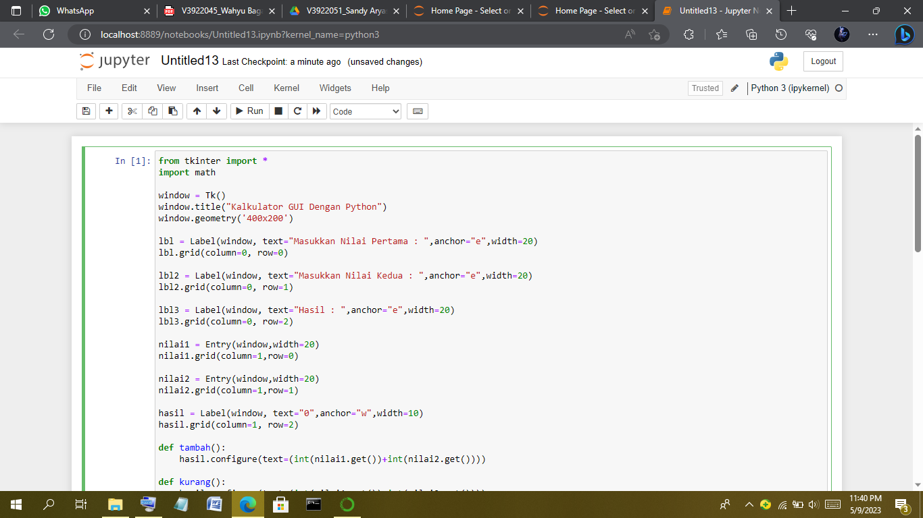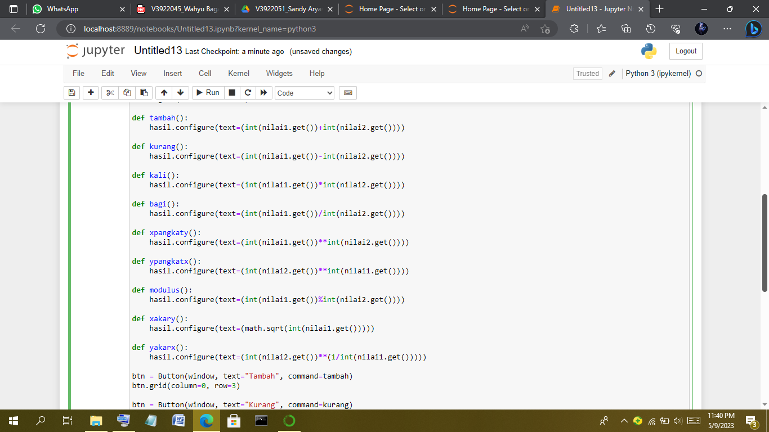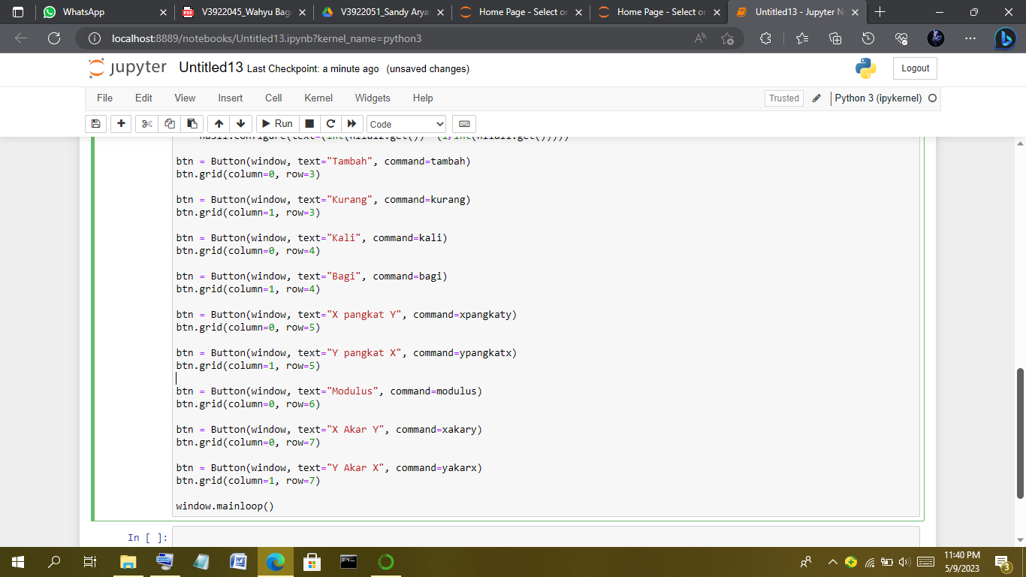

HASIL :

KETIKA DITAMBAH

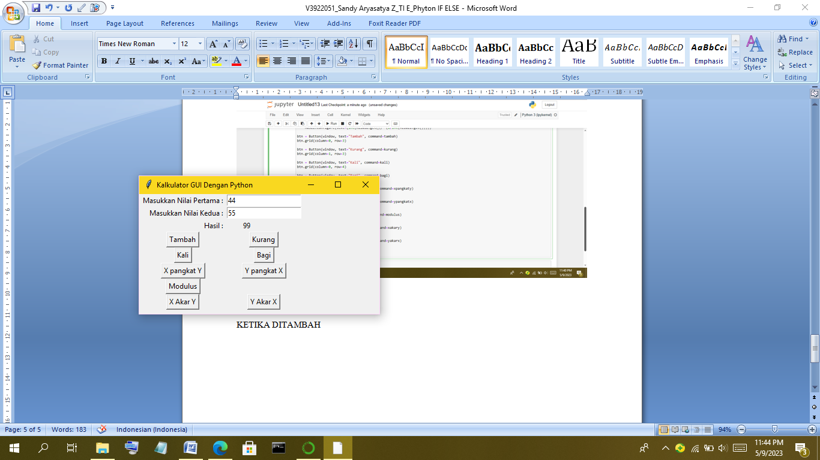

KETIKA DI KALI

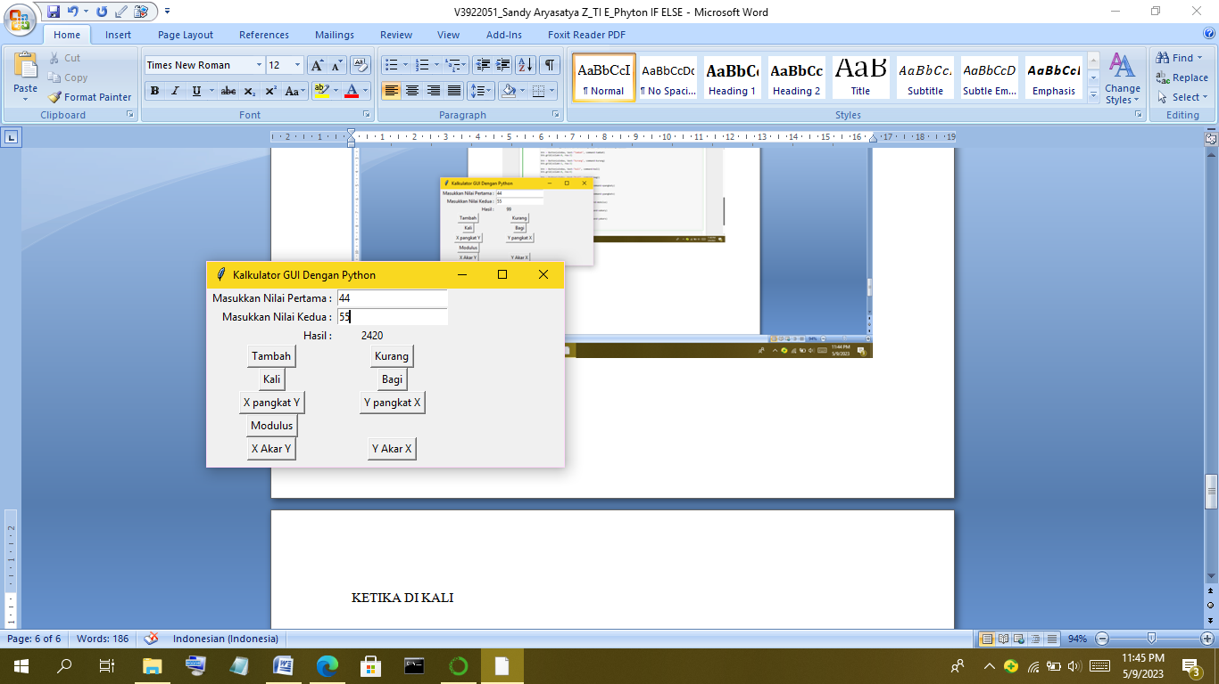

KETIKA X PANGKAT Y

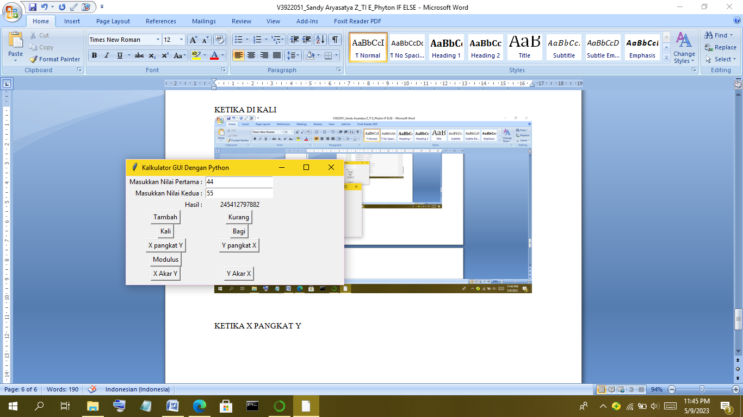

KETIKA MODULUS

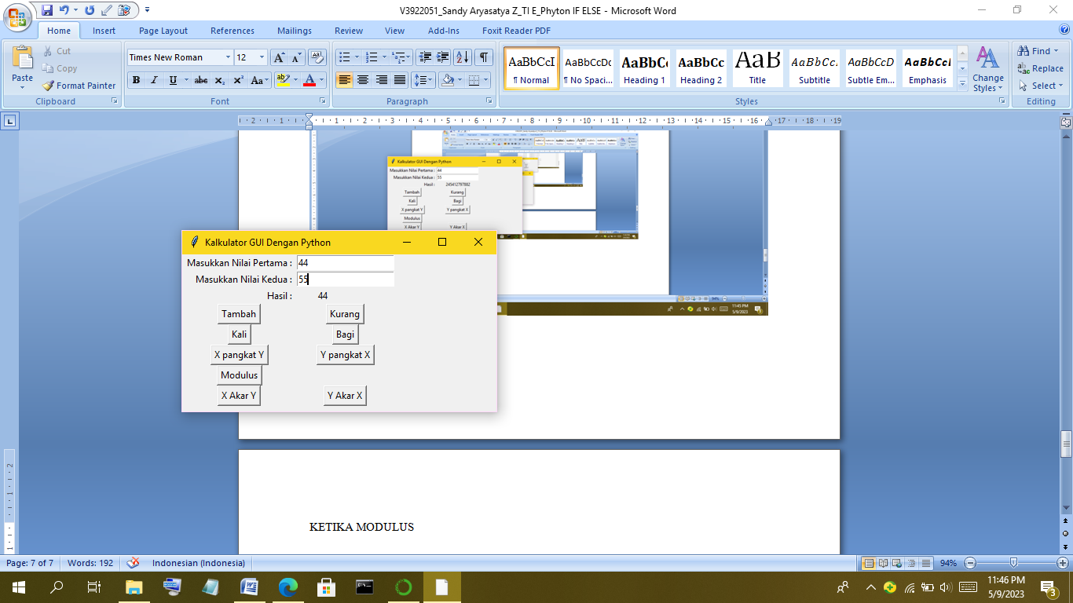

KETIKA X AKAR Y

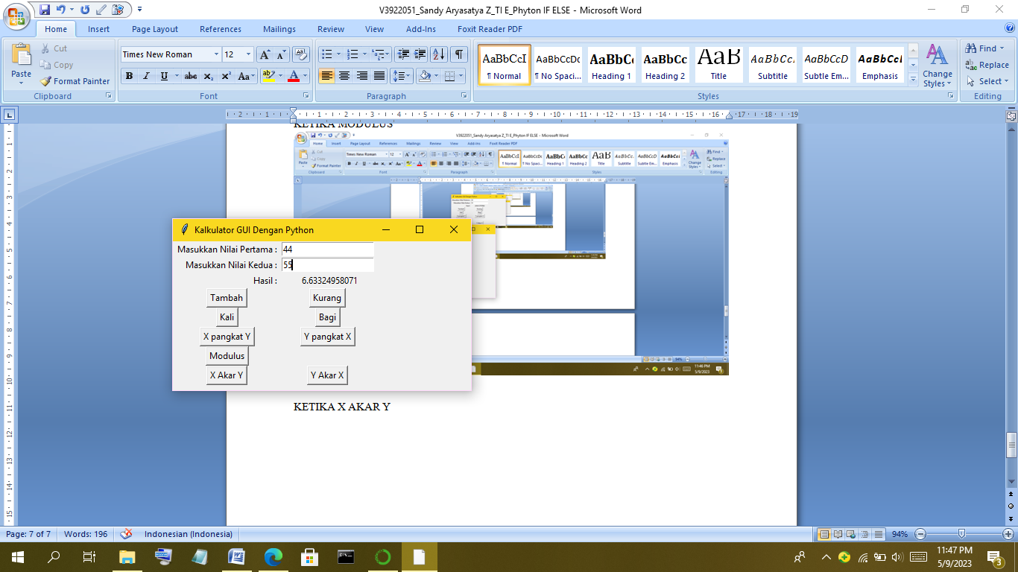

KETIKA KURANG

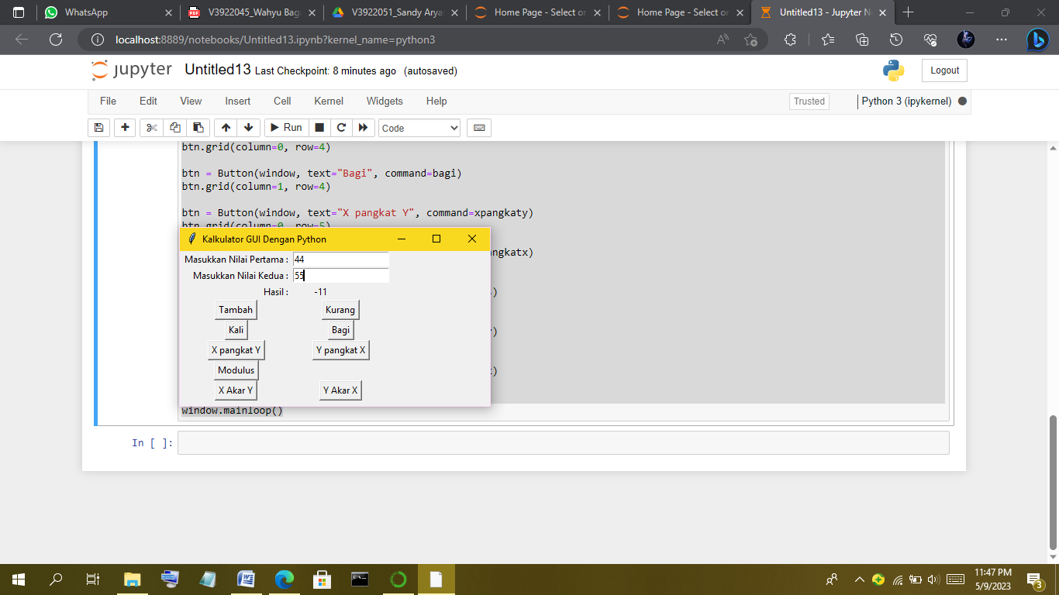

KETIKA DIBAGI

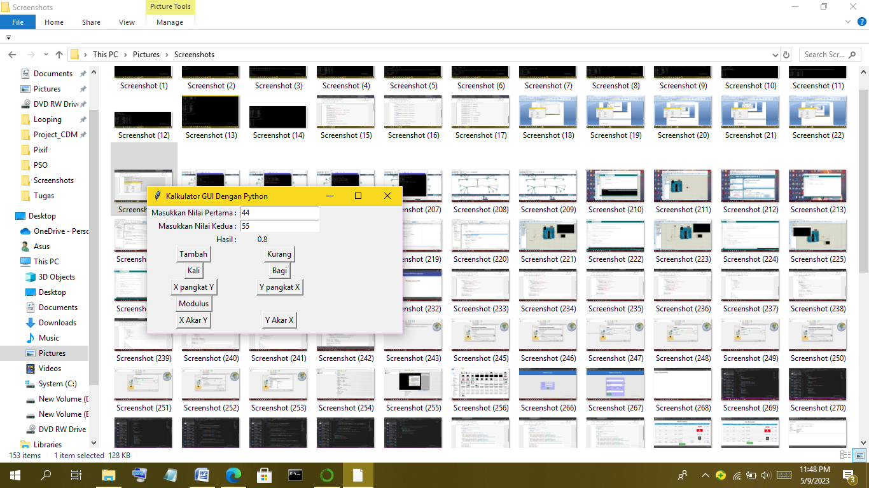

KETIKA Y PANGKAT X

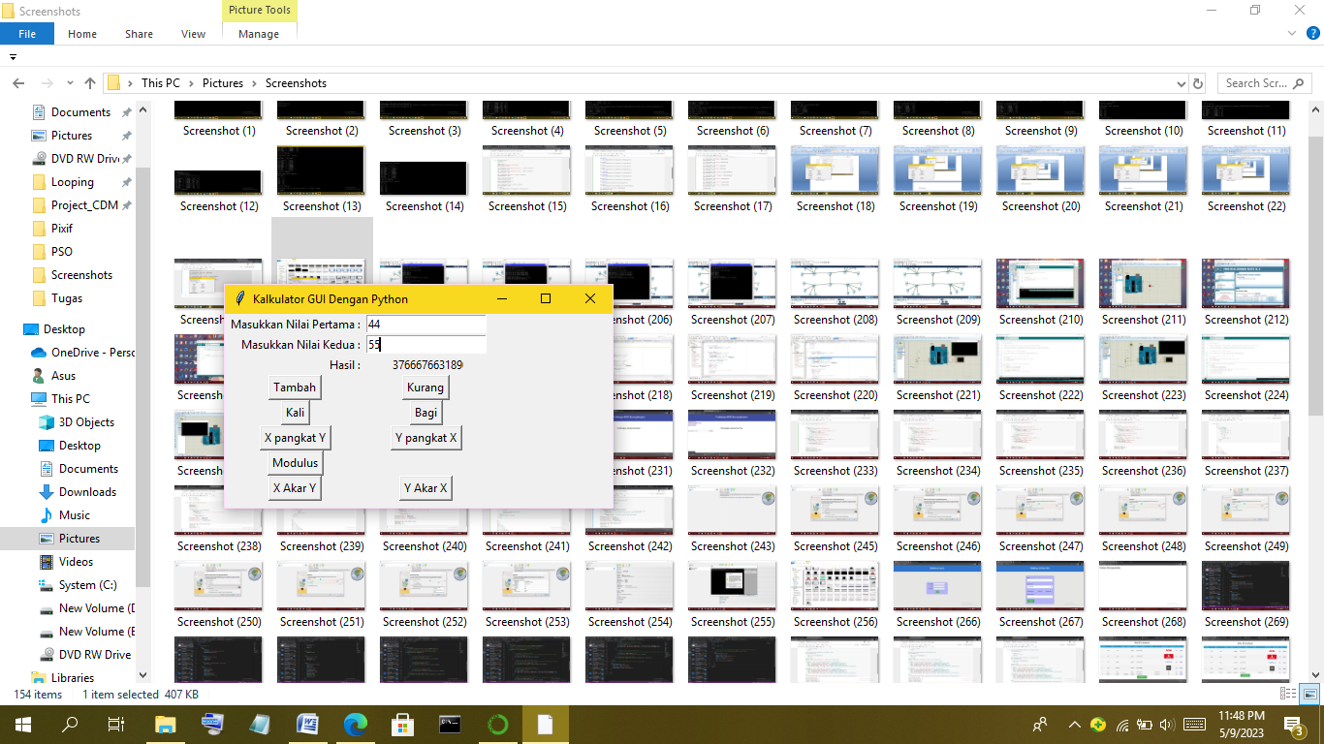

KETIKA Y AKAR X

